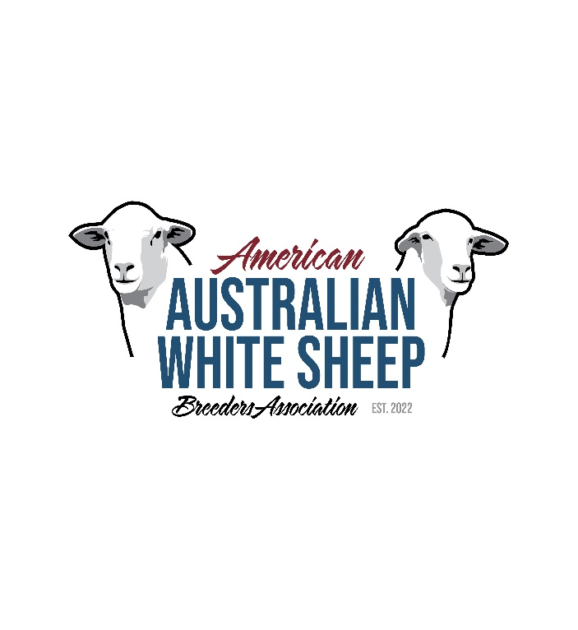**Membership Application**

January – December Annual Membership

Application & Renewal

Annual Membership Fee: $35

Only active AAWSBA members in good standing may record, register or transfer sheep with the Association.

|  |  |  |  |
| --- | --- | --- | --- |
| Date: | Payment: Check # | New Member: _____  Current Member: _____ | *Membership #: _______________  \**Assigned by Office for new members* |
| **Farm Prefix: __________________ First Choice: _______________ Second Choice: _______________  \*\**Three-digit identifier unique to each farm, may be initials or abbreviation of farm name. Assigned by Office for new members.* | | | |

Name: ______________________________________ Farm Name: _________________________________

Address: _________________________________________________________________________________

City: ____________________________________________________ State: __________ Zip: __________

Email: __________________________________ Website: ________________________________________

Phone: _________________________________

**Make Checks Payable to:** AAWSBA or American Australian White Sheep Breeders Association

**Mail to:** AAWSBA, 6600 Little Willow Rd, Payette, Idaho 83661; [info@aawsba.com](mailto:info@aawsba.com), 208-739-5104

|  |  |
| --- | --- |
| AAWSBA questions or concerns contact: | Luke Jones, 217-490-3236, [luke.jones07@hotmail.com](mailto:luke.jones07@hotmail.com), President;  David Krider, 417-254-0901, [kriderdavid@gmail.com](mailto:kriderdavid@gmail.com), Vice President;  Sonia Craig, [caprae2001@gmail.com](mailto:caprae2001@gmail.com), 208-739-5104, Secretary/Treasurer |

General Qualifications of a Member:

Any person, family or corporation interested in the promotion of Australian White Sheep are eligible to become a member of the AAWSBA, and as such is entitled to all privileges of full membership except that, in order to be considered eligible for voting, to participate in Association elections, to hold elective office they shall have: 1) have paid dues for the current year, 2) have no outstanding financial obligation to the Association more than sixty (60) days past due, 3) currently own or in the process of owning Australian White Sheep, 4) not a member or participant in the management of other associations or enterprises so as to be determined by the Board to present a direct conflict of interest with AAWSBA. Each owner and registrant eligible for voting per the above shall be represented by but one membership whether such owner and registrant be an individual, partnership, corporation, association or other entity.

I declare the above information to be true and correct in every way. The flock and membership agree to abide by the Rules, Regulations, Constitution and decisions of the American Australian White Sheep Breeders’ Association.

|  |  |  |  |
| --- | --- | --- | --- |
| Signature: |  | Date: |  |